|  |  |  |  |
| --- | --- | --- | --- |
| 1 | | 2,868 | |
| **NUMERO DE FRONTERAS** | | **ENERGIA AGREGADA** | |
|  | | | |
| 7,928,572 | 60 | | 283,090 |
| INGRESO 2020 | DÍAS CERTIFICADOS 2020 | | ENERGIA RESPALDADA 2020 |
|  | | | |
| 964,916 | 14 | | 39,978 |
| INGRESO 2021 | DÍAS CERTIFICADOS 2021 | | ENERGIA RESPALDADA 2021 |

**HISTORICO REINTEGRO DDV**

|  |  |  |
| --- | --- | --- |
|  | **2020** | **2021** |
| **ENE** | - | - |
| **FEB** | - | - |
| **MAR** | - | 0.36 |
| **ABR** | 2.92 | 0.21 |
| **MAY** | - | 0.39 |
| **JUN** | 2.52 | - |
| **JUL** | 1.77 | - |
| **AGO** | 0.64 | - |
| **SEP** | - | - |
| **OCT** | 0.08 | - |
| **NOV** | - | - |
| **DIC** | - | - |

**Los valores de la tabla están en millones de COP**



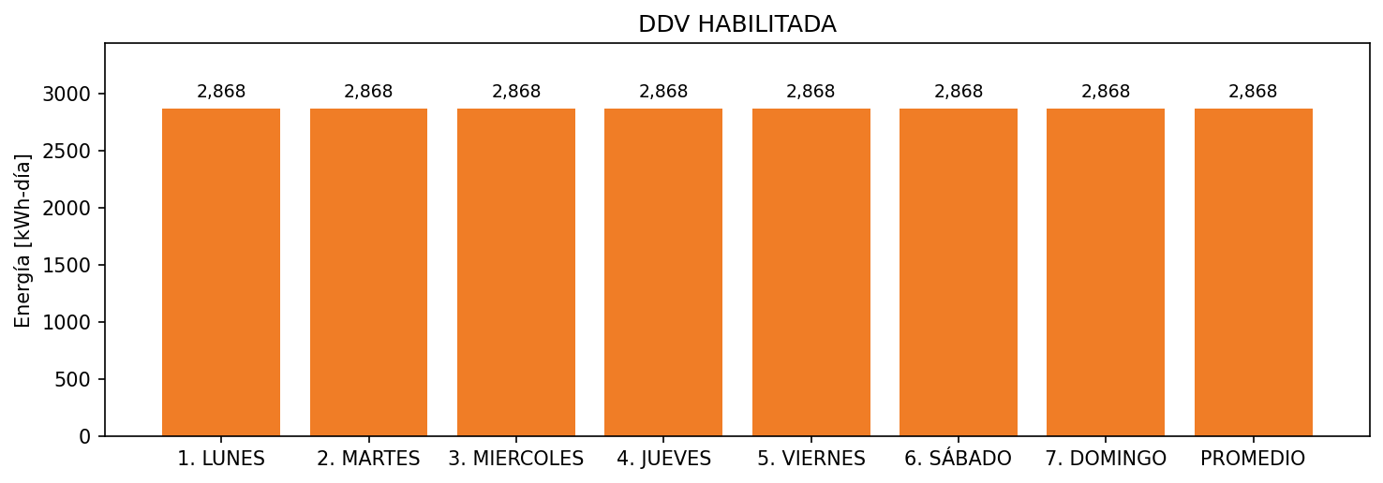

|  |  |  |  |  |  |  |  |  |  |
| --- | --- | --- | --- | --- | --- | --- | --- | --- | --- |
| **FRONTERA** | **COD SIC** | **FRT DDV** | **TIPO DDV** | **PROMEDIO** | **PRÓXIMA ACTUALIZACIÓN** | **MARGEN DE ERROR** | **ÚLTIMA PRUEBA DDV** | **DÍAS PARTICIPACIÓN** | **FECHA REFERENCIA PRÓXIMA PRUEBA DDV** |
| HOTEL EL DORADO | Frt00827 | Frt35877 | LBC | 2,868 | 2022-03-02 | 4,29 | 2020-04-03 | 74.0 | 2021-12-18 |